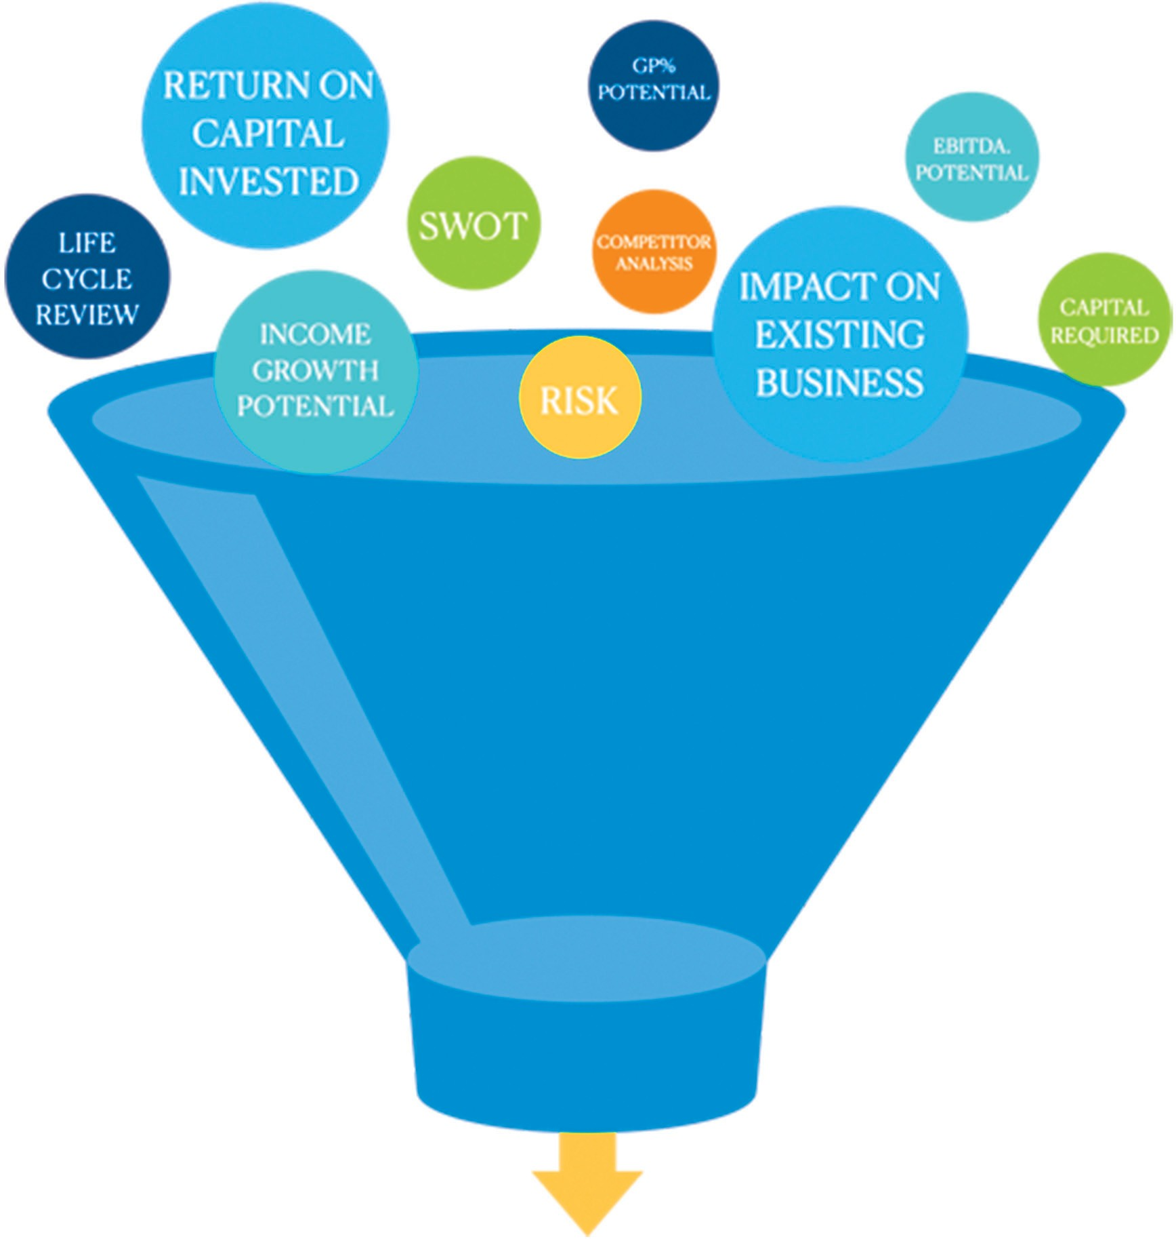
Identifying Big Hairy Audacious Goal Opportunities

