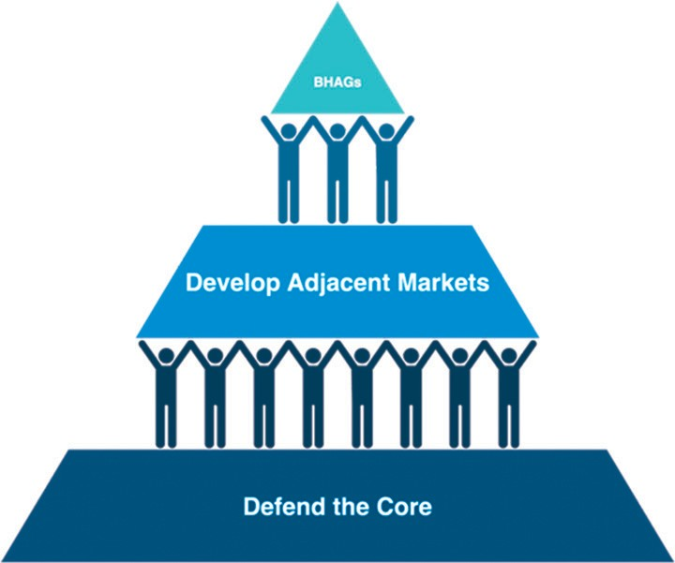
Accelerated Growth Pyramid

